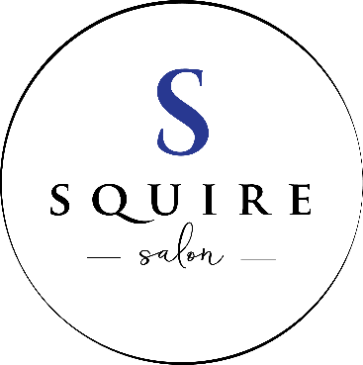

Squire Salon Bridal/special occasion Service Information
First and foremost, CONGRATULATIONS on your engagement!! Planning a wedding can be overwhelming and stressful and our goal is to create a relaxed and enjoyable experience so you can enjoy the most important day of in your life. We will make you look and feel gorgeous while keeping your stress away. Our experienced team is ready to assist you with your picture perfect wedding day.
- Consultation:
- We offer complimentary discussion for the bride/bridesmaid about her hair and all the salon morning details. From here, we can schedule your trial run appointment with the designer who will be working with you on the wedding day look. We will also go over the process for booking your wedding day services and take 50% credit card/cash/check deposit for all services booked for the day.

- Trial Run:
- The trial Run should be booked approximately 2-3 weeks prior to the wedding/special occasion date.
- Tips for your trial run:
- Wear a button down shirt
- Come with clean DRY hair
- Bring veil, head piece and/or hair jewelry if possible
- Bring pictures of looks you like and some that you do NOT like
- Allow 30 minutes for trial run
- Have same color and cut that you will have on your wedding/special day

- Day/week before services:
- Services that are perfect for the week before are; eyebrow shaping, manicures, pedicures
- We do not recommend that you try to coordinate these services on the same day as your wedding. Let your wedding day be relaxed and less stressful so you can focus on any last minute details that may come up.
- Wedding Day Services:
- If you have already had a trial run, then we will re-create the look we achieved during that practice run. (unless you and the stylist have discussed changes prior)
- Everyone in your wedding party is welcome to have services done. In order to stay on schedule and you to the wedding on time, please have all friends/family arrive at the proper time for their appointment(s). If you have last minute additions, please contact us immediately so we may see if we can accommodate.
- Photographers are encouraged and welcomed to attend your “getting ready” process. If there is anything we can do to help your photographer, let us know.
- Complimentary refreshments are provided for your enjoyment. If you would like to bring your own food/drink in for your wedding party, just let us know and we will have an area set up for you. Some brides bring mimosas or fruit, bagels, sandwiches, etc.

- Wedding day recommendations:
- Bride and Bridesmaids:
- Please arrive to your hair design service 10 minutes early
- Please have dry hair.
- Be sure to wear a button down shirt or shirt that is easily removable when you are changing into your formal wear.
- Brides/bridesmaids: please don’t forget your veil, head piece/hair jewelry, flowers, etc that will need to be incorporated into your wedding day look.

- Booking & Pricing
- We have a bridal agreement that helps both of us stay organized. We will list all of your bridal party participants on the form and what they are receiving on your wedding day. We will also take a 50% deposit to book your special day. The 50% is based upon the total amount of services booked.
- Bridal up-do: $60
- Bridesmaids up-do: $60
- Junior bridesmaids (under 10): starts at $30
- Style for short hair: $24
- Style for long hair: starts at $30
- A minimum of 7 day advanced notice is required to cancel individual appointments.
- Appointments that are cancelled with less than 7 day notice, will forfeit their deposit on that service.
- Cancellation of the entire wedding party services must be cancelled within 14 days to receive full refund on the deposit. Cancellations made under 14 days of wedding will result in forfeit of the full deposit.
- ****Please be advised: There will be an additional $50-hourly charge for wedding services that start before 8am or for Sunday weddings.

